Business Support Facility for Resilient Agricultural Value Chains

Guidelines for Call for Applications
Cashew Matching Grant Fund Call 1

May 2023

Table of Contents
List of Abbreviations 3
Section 1: Introduction 5
Section 2: Overview of the Matching Grant Fund (MGF) 6
Section 3: Background 10
Business Support Facility for Resilient Agricultural Value Chains project 10
The MOVE Competitive Cashew initiative (MOVE-ComCashew) 10
Matching Grant Fund 11
Section 4: Guidelines for Matching Grant Fund Applications 12
Objective of the Matching Grant Funds 12
Who can apply for the Matching Grant Fund? 12
Project duration and size 13
Which project activities will be supported under the Matching Grant Fund? 14
Which costs are eligible for reimbursement under the Matching Grant Fund? 16
Project indicators 16
Section 5: Matching Grant Fund Process 18
Flowchart of Matching Grant Fund process 18
Application Process 19
Timelines for the first call: 22
Data Protection 23
Annexes 24

List of Abbreviations

ABF | Agri-Business Facility for Africa
ACA | African Cashew Alliance
ACP | African, Caribbean and Pacific
ATVET | Agricultural technical and vocational education and training institutions
BMGF | Bill & Melinda Gates Foundation
BMZ | German Federal Ministry for Economic Cooperation and Development
CBS | Cooperative Business School
CA | Conservative Agriculture
CBS | Cooperative Business School
CC | Adaption to climate change
CEMAC | Communauté Économique et Monétaire de l'Afrique Centrale
CICC | Consultative International Cashew Council
CNSL | Cashew Nut Shell Liquid
ComCashew  EAC | Competitive Cashew Initiative  East African Community
EC | Inter-institutional Expert Committees
ECOWAS | Economic Community of West African States
EU | European Union
EU-INTPA | European Commission – International Partnerships
FBS | Farmer Business School
FDI | Foreign Direct Investment
GAP | Good Agricultural Practices
GHG | Green House Gas
GIZ | Deutsche Gesellschaft für Internationale Zusammenarbeit (GIZ) GmbH
GmBS | Gender makes Business Sense
iCF | inclusive Contract Farming
iDPP | Integrated Development Partnerships with the Private sector
IPM | Integrated Pest Management
ITC | International Trade Centre
LCU | Local currency unit
LoI | Letter of Intent
MGF | Matching Grant Fund
MoU | Memorandum of Understanding
MOVE | Market Oriented Value chains for jobs and growth in the ECOWAS Region
MSME | Micro, small and medium enterprises
OACPS | Organisation of African, Caribbean and Pacific States
PBS | Processor Business School
RCN | Raw Cashew Nut
REC | Regional Economic Communities
ROM | Result-oriented management review
SADC | Southern African Development Community
SNI | Sustainable Nut Initiative
VC | Value chain

Section 1: Introduction

Are you working in the Cashew sector? Are you from the private sector, with high interest in climate resilience, competitiveness and direct supply linkage with off takers for sustainability?
Do you have a solution that makes the cashew sector less fragmented, more inclusive (for women and youth), sustainable and profitable?
Do you have innovative ideas for the use of cashews and their by-products?
Then this is a unique opportunity for you to realize your goal!

This document summarizes key steps to follow in applying for the cashew Matching Grant Fund, where you may obtain funding to further promote your business.
Kindly continue to read for more information. But before you proceed, please ensure that you have looked at the Readiness Program of the Cashew Matching Grant Fund and all related documents.

Section 2: Overview of the Matching Grant Fund (MGF)

This section offers a quick overview of the Matching Grant Fund. For further details on each part, please keep reading the document.
Objective of the MGF | The overall objective of the Matching Grant Fund is to leverage contributions from partners for the implementation of specific interventions to drive sustainable growth strengthen private sector development and improve the productivity, and profitability of cashew value chain actors in all the 79 ACP countries.
What is an innovative resilient cashew value chain? | Business approaches or models owned or best-practices by the private sector that will support sustainability of cashew value chain and its segments. Segments are primary production, trade, and processing.
Who can apply to the MGF? | Lead applicants  - Processing companies  - Agricultural producer organisations / registered or pre-cooperative structures/networks (GIC and GIC unions)  - Off takers of the main product of the value chain and / or its by-products  Consortium Partners  - Farmers  - Processing companies Private or public research organisations/Universities  - Private Sector Foundation  - Off takers of the main product of the value chain and / or its by-products  - Trading/buying companies  - Financial Institutions  Service Providers  - Agricultural technical and vocational education and training institutions (ATVET)  - National extension organisations (public and private)  - Business development services  - Service providers for e.g., digital platforms  - Financial institutions  - Civil society actors  Note: Women and youth led consortia are encouraged to apply
Eligibility criteria | - Legally registered entity with mandate to enter into binding commercial and cooperation agreements  - Contribution to the project of at least 60% (in cash and/or in kind)  - Annual turnover at least twice the amount of the contract  - Evidence of tax payment in last 2 years for the lead applicant if applicable
Key Performance Indicators (KPI) | - Investments of involved actors (consortia partners, supported MSME, financial institutions) in resilience of value chains  - 75% of the promoted business entities in agriculture, processing, or service provision,  - 50% of activities promoted should be led by women,  - 50% of activities should be led by youth  - professional organisations apply resilient practices  - 60% of supported innovative projects successfully reduce CO2 or store CO2 on the ground in line with internationally recognized standards  - Additional resources are mobilized by project applicants / consortia
Business Support Intervention Activities under the Matching Grant Fund | Capacity building of primary producers through:  - Technical training for primary producers: such as Good Agricultural Practices (GAP), Adaptation to Climate Change (CC), Conservative Agriculture (CA), Agroforestry, Improved planting Material development, etc.  - Entrepreneurial training for primary producers: Topics may include Farmers Business School (FBS), Cooperative Business School (CBS), Gender Make Business Sense (GmBS), Mitigation to Climate Change, Empowerment of women and youth and other entrepreneurial topics.  Other interventions and value chain promotion approaches  In addition to the first two thematic areas, application could also consider following topics/approaches: Contract farming/Supply Chain linkages, Diversification (e. g. intercropping, bee keeping, agroforestry etc), Production and / or use of renewable energy, Optimized supply management and logistic (transport) management including communication, traceability, / digital solutions, Innovations in new products development, Waste recycling / upcycling in commercial products, Cashew by-products use, Cashew Processing, Ecotourism / agrotourism, Certification (Organic, Fairtrade etc.), Digital services (weather forecast, traceability), Integrated Pest Management, Soil fertility management, Post Harvest Management, Carbon credit, Mechanization, Access to finance, Social sustainability (such as awareness raising on child labour, forced labour, etc.)
Project duration and size | Maximum of 24 months after contracting and GIZ amount of maximum 125,000 € for projects with beneficiaries in one country, and up to 500,000 for strategic alliances (where beneficiaries are in multiple countries or several consortia apply jointly)
MGF process steps | - Readiness programme (On-/Offline support to potential applicants to better understand the whole MGF process and put in their applications)  - Call for concept notes (short description of intentions for the project using provided template)  - Assessment of concept notes by inter-institutional expert committee  - Support for full proposal development  - Evaluation and decision for Full proposal for project funding  - Contracting  - Project implementation, including M&E cycle and reporting  - Auditing and closure

Section 3: Background

Business Support Facility for Resilient Agricultural Value Chains project
The “Business Support Facility for Resilient Agriculture Value Chains” is a project to support African, Caribbean and Pacific (ACP) agricultural value chains’ development, co-financed by the European Union (EU) under the Post-Cotonou Agreement with the Organisation of African, Caribbean and Pacific States (OACPS) and by the Federal Ministry of Development and Economic Cooperation (BMZ) and implemented by GIZ.
The project is based on longstanding working experience with the promotion of sustainable agribusiness and value chain (VC) development. Focusing on cashew, cocoa, maize, and livestock value chains, the project aims to contribute to economic and climate resilience of mentioned value chains, as well as food security, increased income, and employment in the 79 ACP countries under Post-Cotonou Agreement.
The project is geared to develop and enhance the capacities of actors along ACP agricultural value chains to attract finance and investment, in particular towards low-emissions and climate resilient practices and value chains through the following outputs:
- Successful agribusiness training approaches and tools are scaled through self-paced e-learning and blended learning (online and face-to-face formats) for cost-effective capacity development in large scale.

- Establishment of a competitive Matching Grant Fund (MGF) to
Maximize outreach across countries and value chains
Foster excellence and ownership and
Mobilize additional resources for implementation. The competitive MGF shall translate the strategic and thematic directions of the component in up to 85 meaningful and cost-effective consortia projects involving private and public actors along VCs

- Experience and achievements under Outputs 1 and 2 are valued with partners for learning, for South-South Cooperation, for further scaling and institutionalizing the approaches of the Business Support Facility.

The Business Support Facility for Resilient Agricultural Value Chain project covers the period from 1st March 2023 until 28th February 2027. It is implemented by two projects of the German Development Cooperation, GIZ, namely MOVE ComCashew working in the cashew value chain and the Agri-Business Facility (ABF), working on cocoa, maize and livestock (sheep, goat, cattle). The current call for proposals is hosted by MOVE ComCashew.
.

The MOVE Competitive Cashew initiative (MOVE-ComCashew)
The Market-Oriented Value Chains for Jobs and Growth in the ECOWAS Region (MOVE) is commissioned by BMZ, with co-financing from the Bill and Melinda Gates Foundation, (BMGF) for rice and European Union (EU) delegation for Ghana. MOVE aims to increase the overall resilience and competitiveness of the cashew and rice value chains in the ECOWAS region and represents the merging of two former GIZ programs: Competitive African Rice Initiative (CARI) and the Competitive Cashew initiative (ComCashew). The program’s five outputs are as follows:
- Output 1: Increasing the value creation of processing in the ECOWAS region.
- Output 2: Improve the economic/environmental sustainability of agricultural systems.
- Output 3: Improving the marketing of regional products.
- Output 4: Disseminating good practices in promoting inclusive business models.
- Output 5: Strengthening public-private cooperation in policymaking.

Matching Grant Fund
The Matching Grant Fund is one of GIZ’s financing tools which will be used in the implementation of Business Support Facility for Resilient Agricultural Value Chains Project Output 2. It would be used as an instrument to leverage contributions from private sector actors such as processors, Farmer Based Organizations (FBOs), buyers or off-takers of cashew and its by-products from the targeted ACP countries.
Under the Matching Grant Fund, private sector partners could apply for grants by submitting project proposals to jointly work on selected challenges of the cashew value chain. Grants will then be assessed and allocated based on a set of eligibility criteria, including a cost-share requirement from the grant recipient.
The Matching Grant Fund will be closely linked to outputs 1, 2, and 5 with the expectation that a properly designed and implemented fund will increase cashew farmers’ income and/or foster a strengthened business model that will improve business profitability. The fund is expected to increase productivity, climate resilience, inclusiveness (women and youth), supply chain linkage and profitability in the cashew value chain.

Section 4: Guidelines for Matching Grant Fund Applications

Objective of the Matching Grant Funds
The overall objective of the Matching Grant Fund is to leverage contributions from partners for the implementation of specific interventions towards the development of the cashew value chain and build ownership to drive sustainable growth in the cashew sector, strengthen private sector development and improve the productivity, profitability of cashew value chain actors in all the 79 ACP countries.

Who can apply for the Matching Grant Fund?
Below may apply for the Matching Grant Fund as part of a consortium.
- Processing companies
- Agricultural producer organizations/ registered or pre-cooperative structures/networks (GIC and GIC unions).
- Private or public research organisations/Universities
- Off takers of cashew and its by-products
- Trading/buying companies.
- Private Sector Foundations
- Financial institutions

Consortium partners can include private sector companies, public sector institutions, and financial institutions. However, lead applicants must come from the private sector working on cashew, being farmer groups, processors or off-takers. In terms of the requirements for a consortium, all partners must be legally recognized and empowered to enter into binding agreements. For the initial application stage, a letter of intent (see Annex 2) from all consortium partners and the concept note/short proposal (see Annex 1) is sufficient. A signed Memorandum of Understanding (MoU) that clarifies the roles, responsibilities and contributions of each partner must eventually also be provided before the Matching Grant Fund contract can be finalized. Where there are pre-existing business linkages between consortium partners prior to the Matching Grant Fund call for proposals, this should be indicated in the proposal as it may be beneficial to the application.
All Matching Grant Fund consortium partners must make a specified contribution to the project, which can be provided in cash or in kind, or a combination of the two. The lead applicant is expected to make the largest contribution. Applicants may also wish to enlist external service providers as part of the proposed project, for example in the provision of training, and coaching. However, it is important to note that these service providers are not consortium partners and are not expected to make a specific contribution to the project.

Eligible Countries for the Cashew Matching Fund Grant include:
- All private sector actors working in cashew, as described above, from the 79 ACP (African, Caribbean and the Pacific) countries are eligible.

Consortium Partner vs Service Provider
What is a consortium partner?
Consortium partners are contractual partners in a Matching Grant Fund project that have entered into an official understanding and intend to present a joint project. They make a specific contribution to the project, whether in cash or in kind.
Example: A cashew processing company + 2 Farmer Cooperatives and/or a buyer
What is a service provider?
A service provider delivers a specific service against payment. They are not part of the formal consortium and are not expected to contribute in cash or in kind to the project.
Example: consulting firm or national training agency as a service provider

Note: Women and youth led consortia are encouraged to apply

Project duration and size
Each Matching Grant Fund project will last approximately two years and must be concluded by December 2025. A final decision on the duration of the project will be made between MOVE ComCashew and the Matching Grant Fund partners during the proposal review stage.
MOVE ComCashew financial contribution for each Matching Grant Fund project will be up to € 125,000 for the entire duration of the project if one project is proposed with beneficiaries in one country. For strategic alliances (where beneficiaries are in multiple countries or several consortia apply jointly), the contribution of GIZ may go up accordingly. For strategic alliances, please note, only one lead applicant must be involved. For all Matching Grant Projects, the contribution of GIZ would be a maximum of 40% of the total budget. For illustration purposes, the table below lists some project sizes and what financial contributions would be expected from MOVE-ComCashew and the partner(s).

  - Table 2: Hypothetical project sizes and breakdown of contributions
Project value (€) | MOVE contribution (%) | MOVE contribution (€) | Contribution from partner(s) (€)
250,000  for one consortium | 40% | 100,000 | 150, 000
350,000  For one consortium | 40% | 140,000, (however this exceeds the 125,000 targets. MOVE ComCashew shall provide 125 000 as its contribution if beneficiaries are from one country) | 230,0000
800,000  for more than one consortium | 40% | 320,000 | 480,000

Thus, the Matching Grant Fund partner(s) will be required to contribute at least 60% of the project’s cost. While each consortium partner is required to make a specified contribution, in-kind contributions, such as staff time, will be included in this calculation.

Which project activities will be supported under the Matching Grant Fund?
Proposed project interventions may aim at addressing the following:
- Sustainable agricultural practices are encouraged, and environmental/climate change resilience is improved.
- Capacities of cashew value chain actors notably producers, processors, off-takers and MSMEs shall be enhanced to attract finance and investment.
- Competitiveness, upgrading and viability of cashew value chain actors in terms of value addition, technology content and conformance to international standards are strengthened,
- Integration of cashew producers, processors, off-takers and MSMEs into national, regional, and global value chains is strengthened,
- Trade and export competitiveness of cashew value chain is improved.
- An enabling environment is set up for fostering access to finance by cashew actors, through value chain finance.
- Nutrition-sensitive cashew value chains are promoted

Capacity building activities should include below training topics/areas of intervention
- Technical training for primary producers: such as Good Agricultural Practices (GAP), Adaptation to Climate Change (CC), Conservative Agriculture (CA), Agroforestry, Improved planting Material development, etc.
- Entrepreneurial training for primary producers: Topics may include Farmers Business School (FBS), Cooperative Business School (CBS), Gender Make Business Sense (GmBS), Mitigation to Climate Change, Empowerment of women and youth and other entrepreneurial topics.

- Other interventions and value chain promotion approaches
In addition to the first two thematic areas, application could also consider below topics/approaches.
- Contract farming/Supply Chain linkages
- Diversification (e. g. intercropping, bee keeping, agroforestry etc.)
- Production and / or use of renewable energy
- Optimized supply management and logistic (transport) management including communication, traceability, / digital solutions.
- Innovations in new products development
- Waste recycling / upcycling in commercial products
- Cashew by-products use
- Cashew Processing
- Ecotourism / agrotourism
- Certification (Organic, Fairtrade etc.)
- Digital services (weather forecast, traceability)
- Integrated Pest Management
- Soil fertility management
- Post Harvest Management
- Carbon credit
- Mechanization
- Access to finance,
- Social sustainability (such as awareness raising on child labour, forced labour, etc.)

Which costs are eligible for reimbursement under the Matching Grant Fund?
Only the actual direct costs (with no mark-ups) immediately incurred by the project are eligible for reimbursement, in accordance with the GIZ contribution agreed in the contract. Costs that exceed the percentage of total costs or the upper limit set by the contract will not be reimbursed. Costs incurred outside of the contract term of the Matching Grant Fund will also not be reimbursed. Overhead costs and other lump-sum amounts, imputed costs, amortization and depreciation, allocations to provisions and profit mark-up or other costing mark-ups are not eligible for reimbursement.
For a more comprehensive guide to which costs are eligible for reimbursement under the Matching Grant Fund, please see Annex 4.

Project indicators
Key performance indicators, which will be used to measure the success or failure of the Matching Grant Fund projects, will be discussed, and agreed upon during the application process. They may include the following (with the first two (income, climate resilience and gender) being mandatory for all applicants and the rest optional). This means all applicants must work on and report back to the MOVE project on the first 3 topics in addition to any others of their choice from the rest.

- Income & turnover
- Average increased income of supplying agricultural MSME
- Turnover of producer organisations from services provided to their members
- Turnover in processing

- Climate Resilience & Gender
- Contribution to climate resilience (adaptation and/or mitigation/CO2 reduction and/storage)
- Strengthening women and youth, who should make up 50% of the proposed intervention each, in access to resources, to education, to business opportunities & linkages, investment-related decision making and finance

- Job creation & producer organisations
- Jobs created in primary production.
- Jobs created in processing.
- Jobs created in services (technical, digital, financial services)
- Increase member base of producer organisations (increase, mergers, unions)

- Food security and export
- Contribution to food security via supply of food (products) to markets
- Contributions to substitute imports of food products or of ingredients for (food) industry
- Foreign currency earnings from export

- Innovation
- Innovation in primary production
- Innovation in processing for process optimization, efficiency and quality efficiency in processing and technology

- Innovation in technology development
- Innovation in technical services
- Innovation in digital services
- Innovation in business services (information on markets & finance, buyers,
- Scaling of evidence-based approaches / technologies, innovations
- Consolidated sourcing base

It is also important to note that including and empowering women and youth within the cashew value chain is a key objective of MOVE- ComCashew Matching Grant Fund. Applicants should indicate in their proposals if there are women and young people represented in the management or ownership of the organization as this will be looked upon favorably during the selection process. Applicants should clearly explain how they plan to ensure that at least 50 % of the project’s beneficiaries (e.g. training participants, management of the firm or business unit) are women and the youth.

Section 5: Matching Grant Fund Process

Flowchart of Matching Grant Fund process

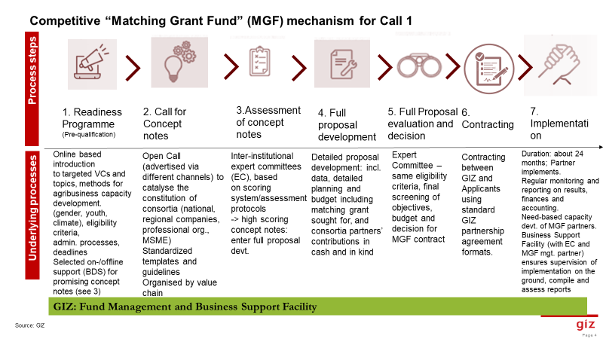

The Matching Grant Fund process will begin with a publicized call for concept notes. Once MOVE ComCashew has received all completed concept notes, it will be assessed and evaluated by an expert committee. Shortlisted applicants will then be invited to develop a full technical proposal and budget.
During this stage, MOVE ComCashew technical team will work closely with the shortlisted applicants to help refine the concept and to ensure the final proposal meets the requirements of the entire MGF criteria. Once a final decision has been made on which projects will be supported, contracts will then be prepared.
The Matching Grant Fund shall be managed by MOVE ComCashew. There will be a Matching Grant Fund Expert Committee which comprises individuals selected based on specific profiles (validated by donors) from targeted Partner institutions in respective countries that shall evaluate the concept notes as well as full proposals based on pre-validated scoring criteria. Final decision on which projects shall be financed would be taken by the Matching Grant Fund Board, made up of the OACPs, European union, African Cashew Alliance and GIZ.

Application Process

- Readiness Program: All documents, guidelines about the Matching Grant Fund application and entire process shall be made available on MOVE ComCashew (www.comcashew.org ) and partner websites (example; OACPS Homepage - OACPS, Consultative Internationa Cashew Council Accueil (ciccashew.org), and African Cashew Alliance African Cashew Alliance) before launch of the call. Training materials such as Farmer Business school shall equally be made available to potential applicants of the Matching Grant Fund. In addition, webinars, on the application process shall be organized prior to the first call for applications. Partners would have the opportunity to ask all questions by contacting MOVE ComCashew via cashew@giz.de before the launch of the call.

- The call for concept notes will be officially announced and circulated through a number of channels to maximize its reach. It will be published online, building on the accessible resources of the readiness programme, including standardized templates and guidelines provided. Potential partners and consortia have the chance to submit concept notes that must, however, align with agreed-upon quality and eligibility criteria according to the Cashew value chain. Eligible for the MGF are private companies, professional organizations of MSME’s in cashew up and downstream value chain segments. Other qualified service providers such as agricultural technical and vocational education and training institutions (ATVET), extension agencies and/or research entities may be proposed by the consortia as service providers

The concept note/short proposal will provide information about the prospective partners’ interest, with details on the Matching Fund partner/consortium and the proposed interventions. Applicants must send a completed concept note/ short proposal, for which a template is provided (see Annex 1) by 24 July 2023 to be considered for support through the Matching Grant Fund. A signed letter of intent is also expected from all consortia partners (see Annex 2).

- Evaluation of Concept notes: The assessment of the concept notes received from applicants shall be done by a designated Expert Committee. The Expert Committee is a pool of selected experts in the cashew sector. With their long-existing experience and expertise in the cashew sector, the Expert Committee Members are well acknowledged and trusted by the industry with the ability to fairly score applicants’ proposals for this Matching Grant Fund. Expert Committee Members are experts from several institutions such as: The Consultative International Cashew Council (CICC),
Members of the Expert Committee should have: Sound knowledge and expertise in cashew value chain, a good understanding of supply chain linkages and environmental resilience in cashew.
Scoring systems and assessment protocols are prepared by MOVE ComCashew and validated by EU and OACPS and other strategic / political partners. Only high scoring concept notes will be selected and enter the second phase of readiness programme for full proposal development. The Expert Committee will review all concept notes that are submitted and assign an overall score according to technical criteria. For example, it will assess how well each proposed project addresses key weaknesses in the cashew value chain. To maximize the chances of their proposed project being shortlisted, applicants are encouraged to read these guidelines carefully and provide detailed information as required in the concept note template.
The concept notes will be assessed using the following criteria in line with the information required in the concept note template:

- Full Proposal Development: Shortlisted applicants will be contacted and asked to submit a full technical proposal and budget using an appropriate template via this link. Applying consortia will need to provide more information and additional data for the same eligibility criteria and to develop detailed and operationalized strategies. The second phase of readiness programme will therefore provide further tools and information on proposal design, building modules for the strategy requirements, planning and information on indicators to be achieved, budgeting tools, including eligibility of cost-items for the pre-selected applicants. For the budget, the detailed partner contributions (in cash and in kind) and GIZ contribution sought for must be prepared. Regarding cost items, investments can be eligible whilst daily operation cost of ongoing business would, for instance, not be eligible. All requested information including annexes as relevant need to be provided to be eligible.
During this stage, a commercial suitability assessment will be conducted. In some cases, lead applicants may also have to undergo a reputational risk analysis.

- For evaluation of full proposals, the Expert Committee will assess and score the full proposals according to the eligibility criteria and prepare an overview of the scores for final approval by the Cashew Matching Grant Fund Board. The final decision regarding applications will be issued in a timely manner after the submission of the full technical proposals and budgets and will be communicated in writing to all applicants.

Funding for validated full proposals will be provided under the categories
- One consortium: up to 125,00 EUR
- Strategic alliances: more than 125,000 EUR including audit

Applicants may refer to Guideline for eligible cost document via this link for more information.
The number of projects selected will ultimately be determined by the budget available to MOVE ComCashew. For this reason, applicants that are not selected for this call are strongly encouraged to reapply for Matching Grant Fund support in subsequent calls.

- Contracting and Implementation: Following approval by the Board, a project implementation contract shall be prepared between MOVE ComCashew and the lead applicant representing the consortium. MOVE ComCashew finance and administration team will also be in contact to explain the nature of the contract and answer any questions, in addition to planned webinars. Integrated Development Partnership Agreement of GIZ (iDPP) would be used for all private sector led applications. Here the private partner must mobilize at least 60% of the total resources needed.
The (lead) applicant shall be legally responsible for the project’s implementation and will consult regularly with MOVE ComCashew project team, who will be available on an ongoing basis to provide assistance. The agreed funding shall subsequently be released to the (lead) applicant to implement the approved activities, according to the agreed schedule of disbursement.
In terms of reporting requirements, the lead applicant will be required to provide regular technical and financial reports(bi-annually) that will be focused on the key interventions tied to the constraints that the Matching Grant Fund investment is addressing. An external audit will be performed for projects with budget exceeding 125 000EUR. Customized requirements related to the specific conditions and set-up of the partners/consortia may be considered and agreed on during the contracting phase.
At the end of the agreed project period, once the Final Technical and financial reports are received from Lead applicant and the final external audit report (where applicable) have been submitted, MOVE ComCashew will formally close the project.

Timelines for the first call:
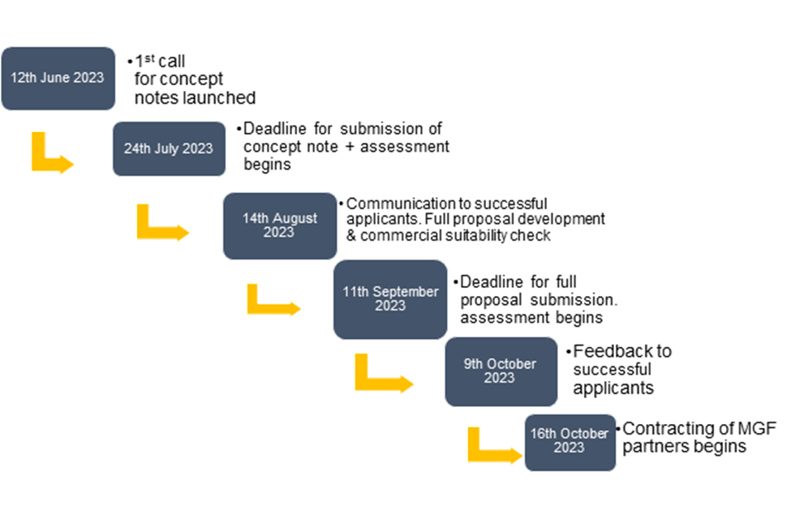

Data Protection
For Matching Grant Fund applicants, please note that information will only be used internally for the process of partner selection and assessment of proposals and will not be shared without the prior consent of the applicants. Please do not hesitate to contact the Market Oriented Value Chains for Jobs and Growth in ECOWAS (MOVE ComCashew) team for further clarification.

Annexes
Annex 1: Eligibility Criteria
Annex 2: Concept note template
Annex 3: Letter of intent template
Annex 4: Guidelines on costs eligible for reimbursement

